NAME: RAJA RAYYAN AMEER
REG. NO.: 23-CP-25
SECTION: ALPHA
SUBJECT: DATABASE MANAGEMENT SYSTEM
DEPARTMENT: COMPUTER ENGINEERING
TEACHER: SIR SHAHID
OPEN END LAB
Problem Statement:
The purpose of this project is to design a Men Barbershop Management System database. As in Pakistan, no one uses it in their Barbershop, with the exception of the ones for the Elite Class. So, this Management will cover the Local Areas, and the Middle Class and Lower Middle-Class Ones. It stores and manages clients, barbers, services, bookings, and payments. The system helps track appointments, payments, loyal customers, and service details efficiently.
ERD (Entity–Relationship Diagram):
Table clients {
id int pk
name varchar
phone varchar
membership_level varchar
joined_date date
}

Table barbers {
id int pk
name varchar
specialty varchar
experience_years int
salary int
}

Table barber_services {
id int pk
service_name varchar
price int
duration_minutes int
service_level varchar
}

Table bookings {
id int pk
client_id int [not null]
barber_id int [not null]
service_id int [not null]
booking_date datetime
status varchar
}

Table transactions {
id int pk
booking_id int [not null]
amount int
payment_method varchar
payment_date datetime
}

Ref: bookings.client_id > clients.id
Ref: bookings.barber_id > barbers.id
Ref: bookings.service_id > barber_services.id

Ref: transactions.booking_id > bookings.id
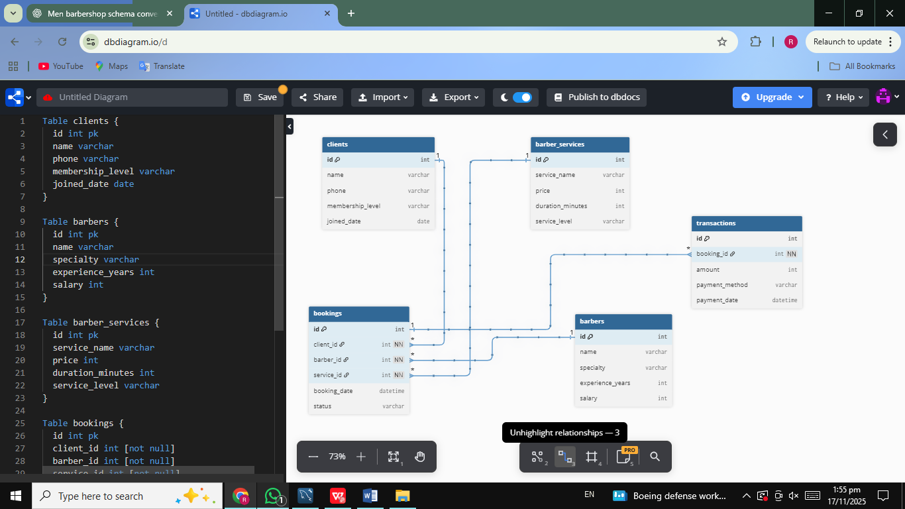
DDL (All CREATE TABLE Queries):
CREATE DATABASE OEL_Lab9;
USE OEL_Lab9;

CREATE TABLE clients (
id INT PRIMARY KEY,
name VARCHAR(100) NOT NULL,
phone VARCHAR(20),
membership_level VARCHAR(50),
joined_date DATE
);

CREATE TABLE barbers (
id INT PRIMARY KEY,
name VARCHAR(100) NOT NULL,
specialty VARCHAR(100),
experience_years INT,
salary INT
);

CREATE TABLE barber_services (
id INT PRIMARY KEY,
service_name VARCHAR(100) NOT NULL,
price INT NOT NULL,
duration_minutes INT,
service_level VARCHAR(50)
);

CREATE TABLE bookings (
id INT PRIMARY KEY,
client_id INT NOT NULL,
barber_id INT NOT NULL,
service_id INT NOT NULL,
booking_date DATETIME,
status VARCHAR(50),

FOREIGN KEY (client_id) REFERENCES clients(id),
FOREIGN KEY (barber_id) REFERENCES barbers(id),
FOREIGN KEY (service_id) REFERENCES barber_services(id)
);

CREATE TABLE transactions (
id INT PRIMARY KEY,
booking_id INT NOT NULL,
amount INT,
payment_method VARCHAR(50),
payment_date DATETIME,

FOREIGN KEY (booking_id) REFERENCES bookings(id)
);
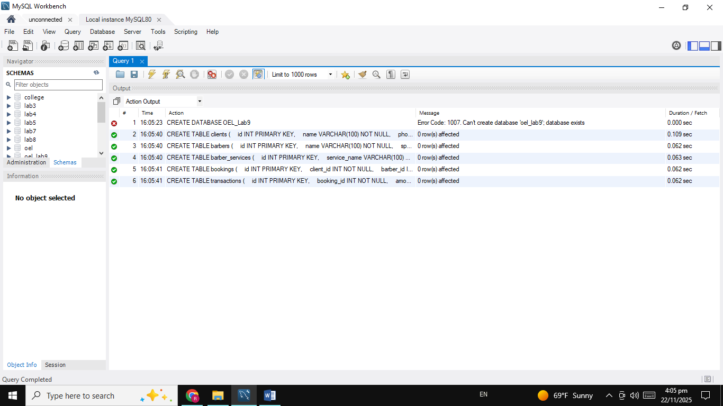
Sample INSERTS:
INSERT INTO clients (id, name, phone, membership_level, joined_date)
VALUES (1, 'Ali Khan', '03001234567', 'Regular', '2025-01-01');

INSERT INTO barbers (id, name, specialty, experience_years, salary)
VALUES (1, 'Kamran', 'Fade Haircut', 5, 35000);

INSERT INTO barber_services (id, service_name, price, duration_minutes, service_level)
VALUES (1, 'Classic Haircut', 800, 30, 'Basic');

INSERT INTO bookings (id, client_id, barber_id, service_id, booking_date, status)
VALUES (1, 1, 1, 1, '2025-01-05 15:00:00', 'Booked');

INSERT INTO transactions (id, booking_id, amount, payment_method, payment_date)
VALUES (1, 1, 800, 'Cash', '2025-01-05 15:30:00');
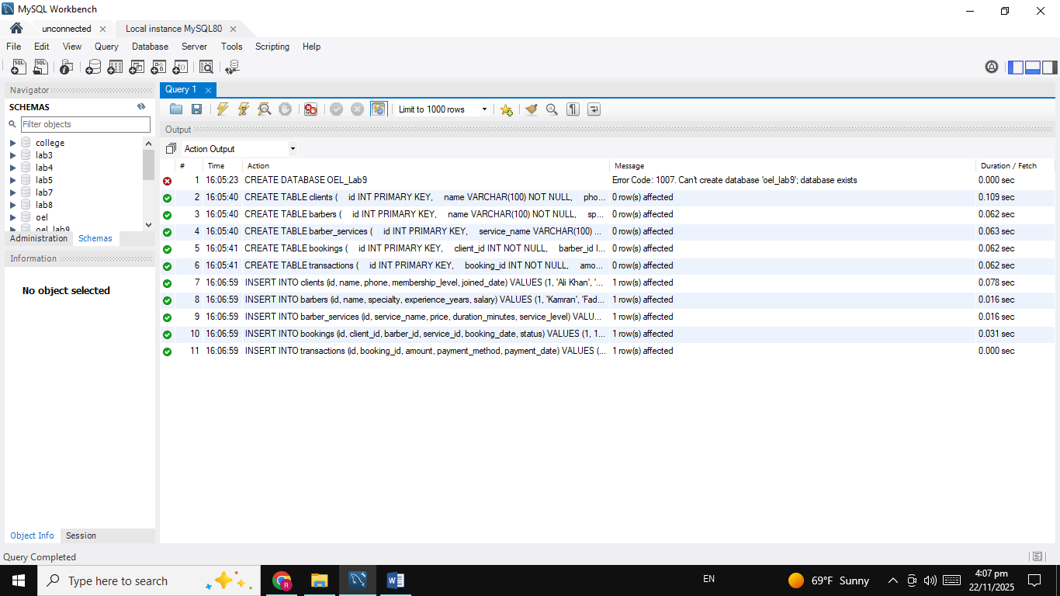
Queries:
INSERT INTO clients (id, name, phone, membership_level, joined_date)
VALUES (1, 'Ali Khan', '03001234567', 'Regular', '2025-01-01');

INSERT INTO barbers (id, name, specialty, experience_years, salary)
VALUES (1, 'Kamran', 'Fade Haircut', 5, 35000);

INSERT INTO barber_services (id, service_name, price, duration_minutes, service_level)
VALUES (1, 'Classic Haircut', 800, 30, 'Basic');

INSERT INTO bookings (id, client_id, barber_id, service_id, booking_date, status)
VALUES (1, 1, 1, 1, '2025-01-05 15:00:00', 'Booked');

INSERT INTO transactions (id, booking_id, amount, payment_method, payment_date)
VALUES (1, 1, 800, 'Cash', '2025-01-05 15:30:00');

SELECT * FROM clients;
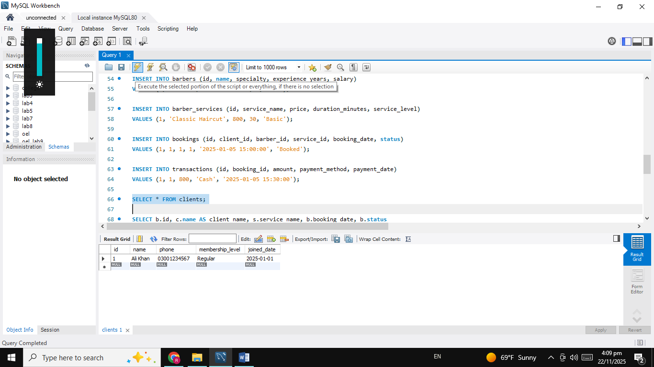
SELECT b.id, c.name AS client_name, s.service_name, b.booking_date, b.status
FROM bookings b
JOIN clients c ON b.client_id = c.id
JOIN barber_services s ON b.service_id = s.id;
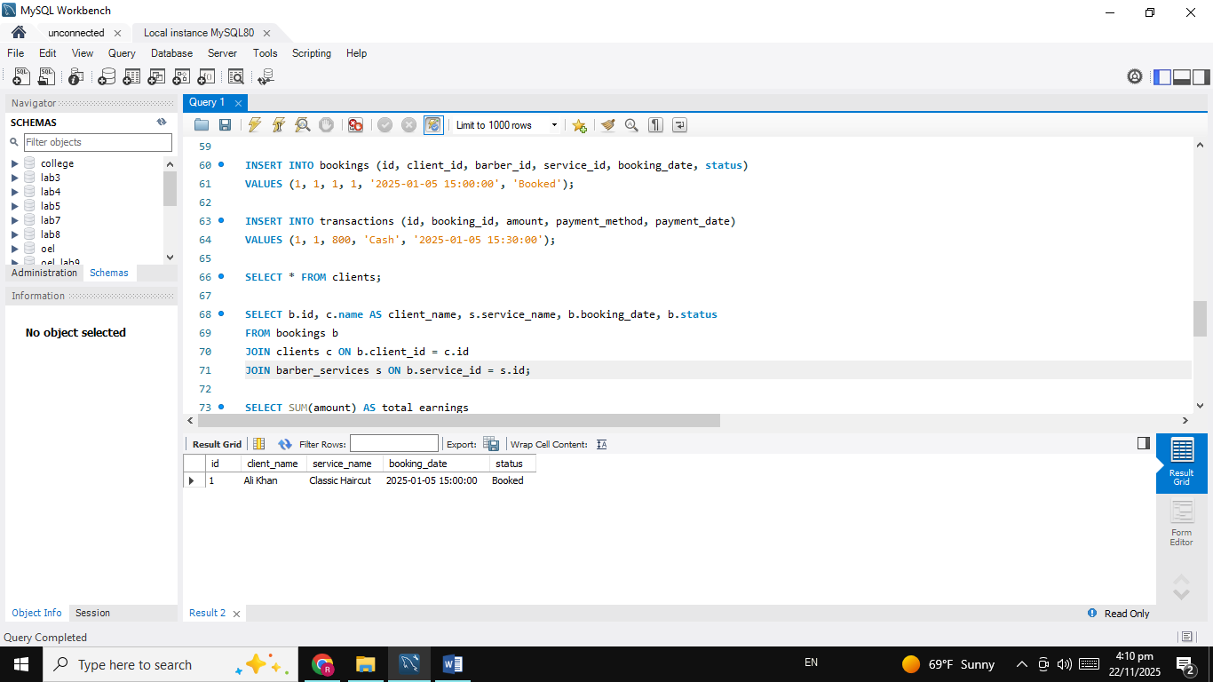
SELECT SUM(amount) AS total_earnings
FROM transactions;
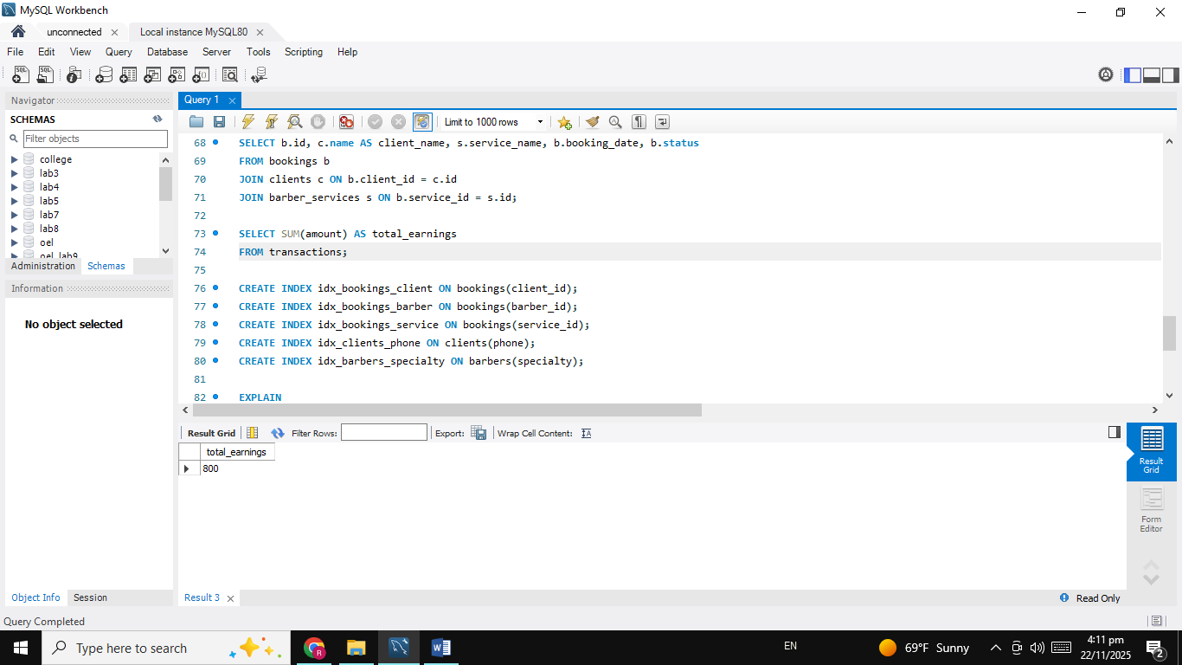
Two Views:
CREATE VIEW view_booking_details AS
SELECT b.id, c.name, s.service_name, b.booking_date, b.status
FROM bookings b
JOIN clients c ON b.client_id = c.id
JOIN barber_services s ON b.service_id = s.id;
SELECT * FROM view_booking_details;
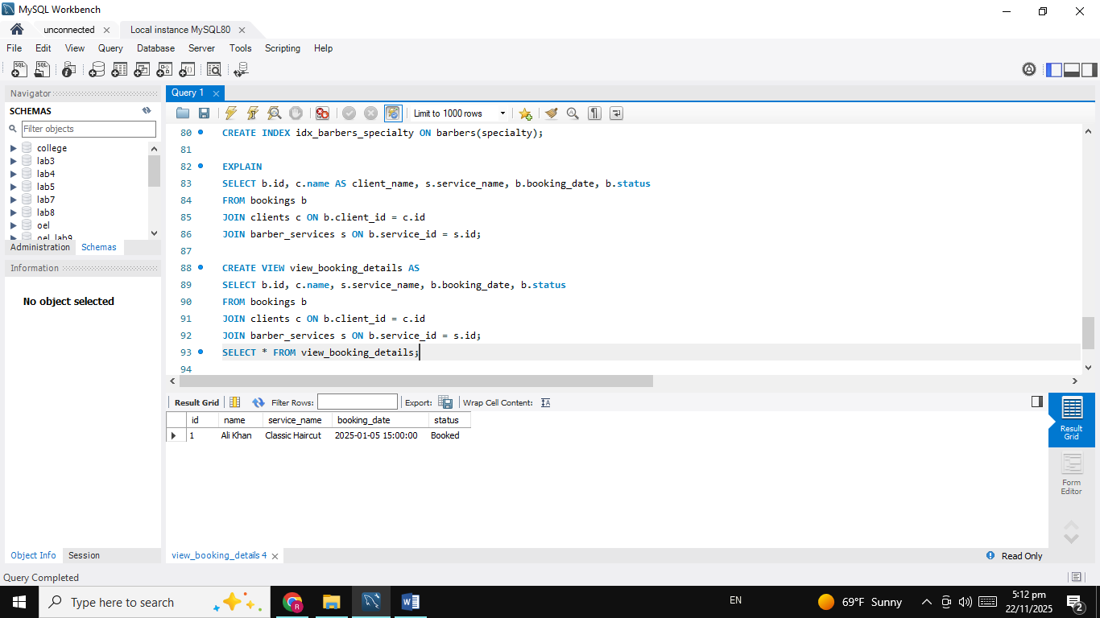
CREATE VIEW view_client_info AS
SELECT name, phone, membership_level
FROM clients;
SELECT * FROM view_client_info;
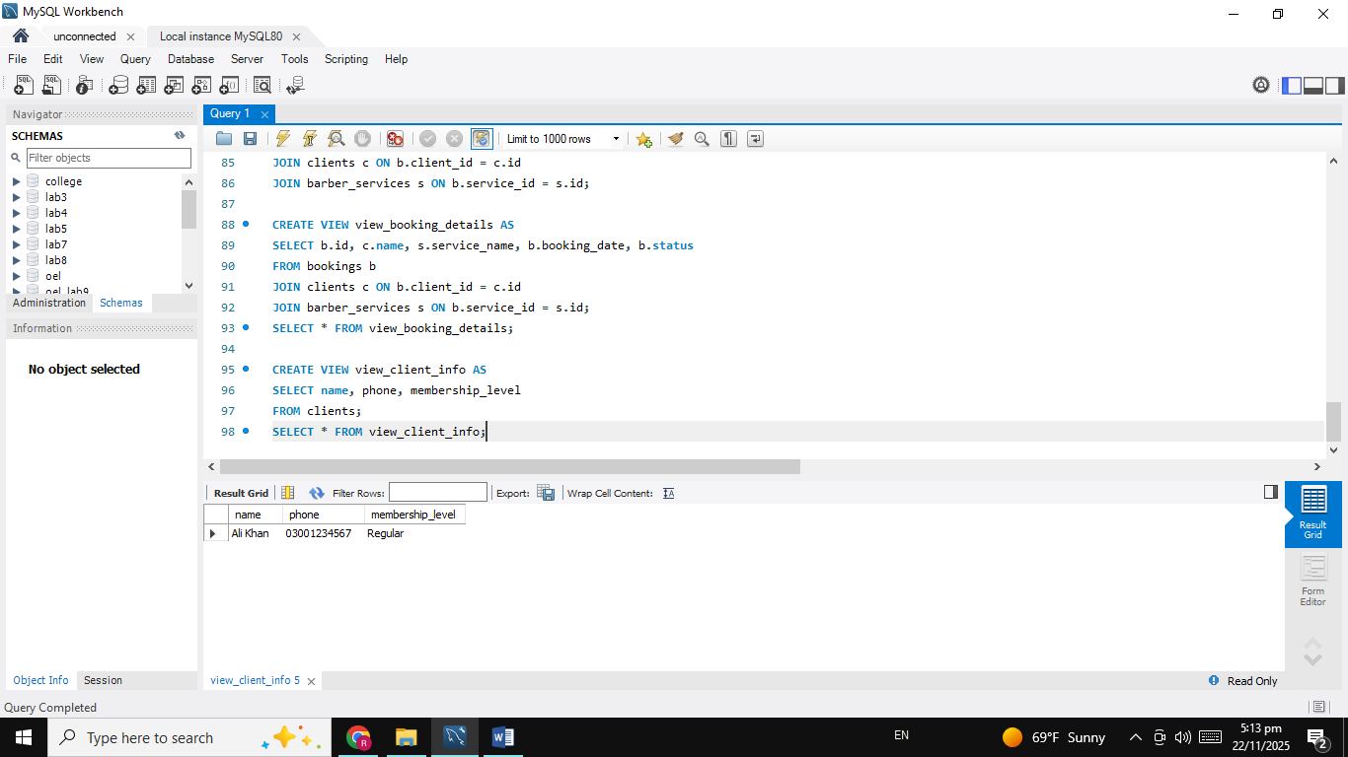
Five Indexes:
CREATE INDEX idx_bookings_client ON bookings(client_id);
CREATE INDEX idx_bookings_barber ON bookings(barber_id);
CREATE INDEX idx_bookings_service ON bookings(service_id);
CREATE INDEX idx_clients_phone ON clients(phone);
CREATE INDEX idx_barbers_specialty ON barbers(specialty);
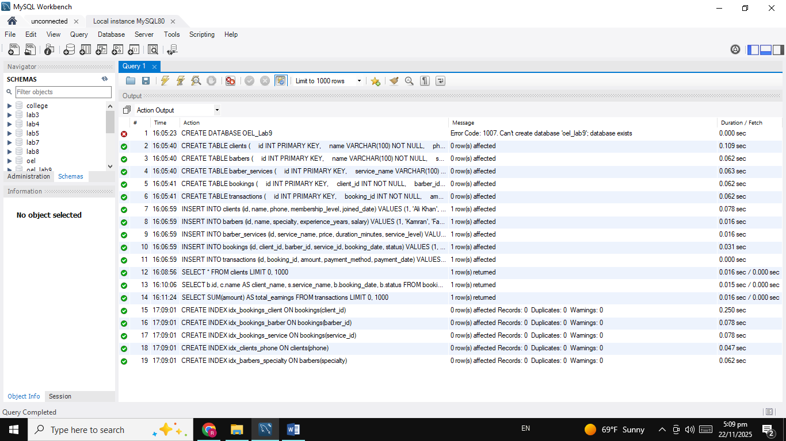
Before & After Indexing:
Before Indexing:
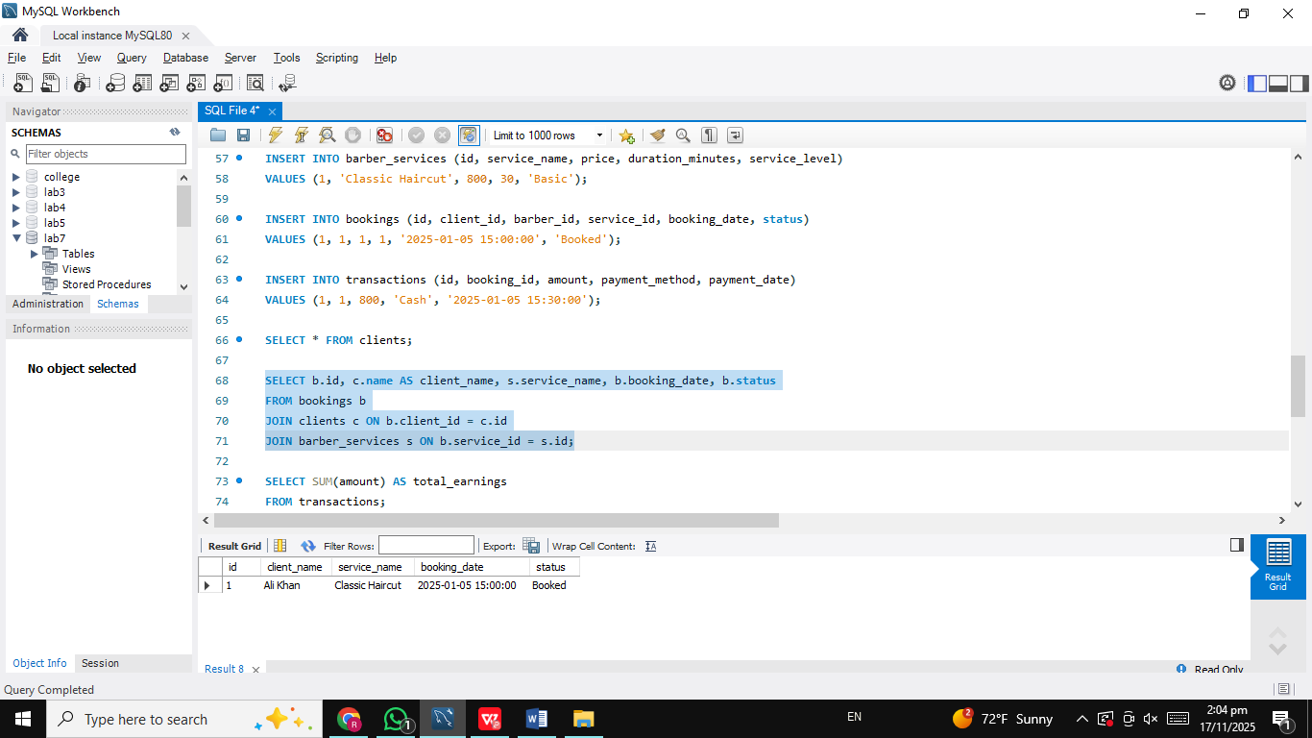
After Indexing:
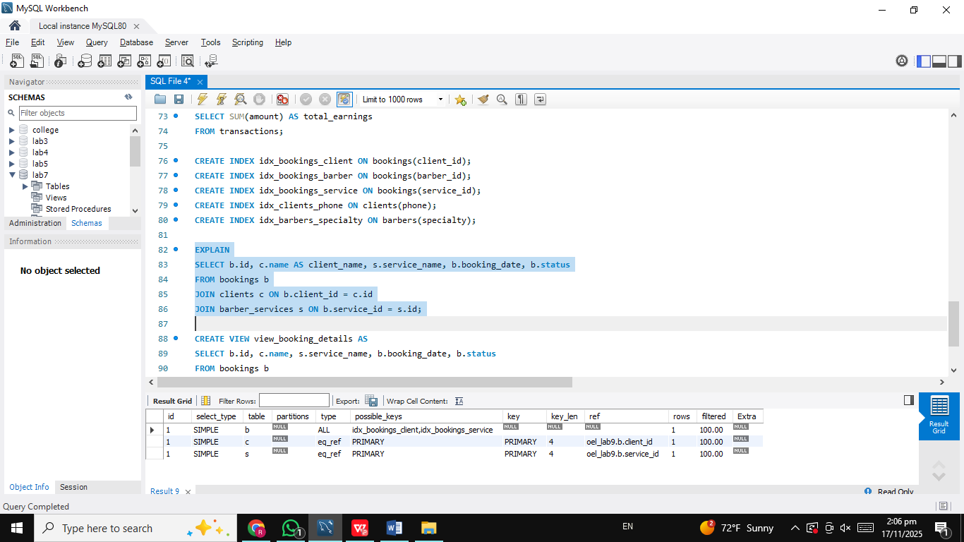
1-Slide Summary of Insights
- What Indexing Improved
- Queries became faster, especially when searching.
- The database loads booking information quickly because indexes reduce scan time.
- Number of Tables
- Total 5 Tables: clients, barbers, barber_services, bookings, transactions.
- Why This Database Helps Barbershops
- Keeps all client, barber, and service records organized.
- Makes it easy to track bookings, payments, and earnings.
- Reduces manual work → saves time, fewer mistakes.
- Helps shop owners check which services sell most and which barber is busiest.
- What I Learned
- How to design a complete database from scratch.
- How foreign keys connect tables.
- How indexes make queries faster.
- How to use EXPLAIN ANALYZE to measure performance.
- How to write DDL, inserts, joins, and reports.
______________________________________________________________________________
THE END

